**Train Reports**

**Passenger Report (multi table report from passenger and ticket tables)**

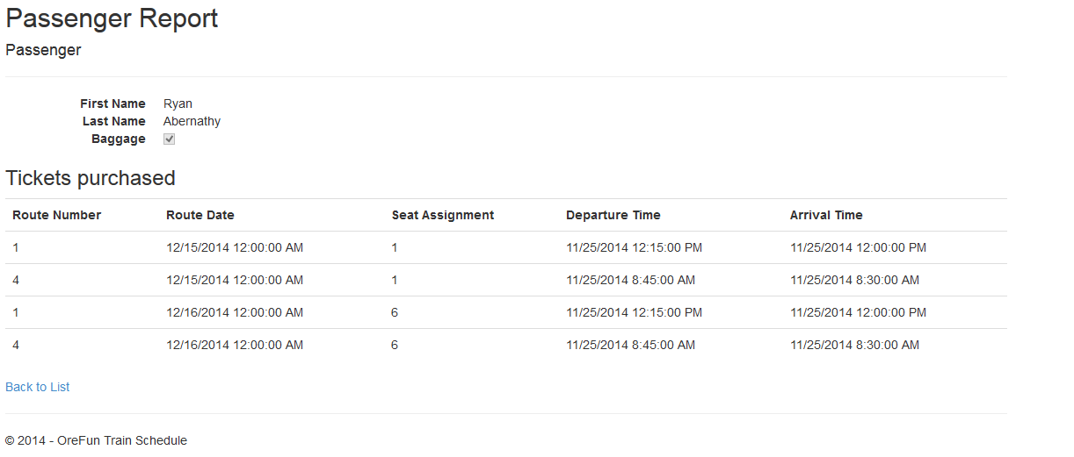

**Route Report (multi table report from route and station tables)**

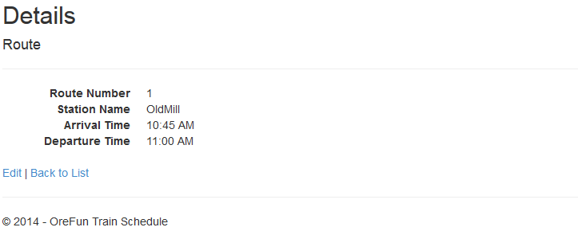

**Station Report**

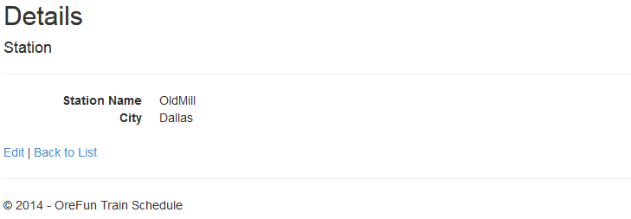

**Ticket Report (multi table report from passenger and ticket tables)**

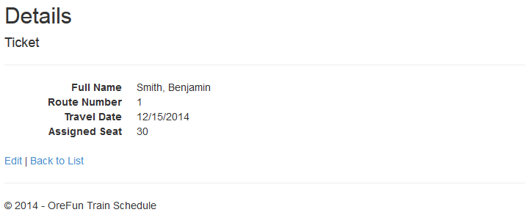

**Train Report**

